Dear students (and parents) of Mr. Bryant’s Honors Math 3,
First, I hope everyone is staying safe, happy, and healthy in this crazy time.
Second, I’ve missed you!!!! Very excited that the county has allowed us to start instruction again and ready to get to work. I know things are very uneasy at this time with more questions than answers, but know that we are in this together and everything we do is for you guys. I do ask you guys to work hard and to be flexible as there will be a learning curve for everyone (me included!). I’m confident with the plans we’re putting into place that this can be a great, successful semester for everyone. While a lot of remote learning is more independent than the classroom, know that I’ll be there to help any way that I can. We can do this!
For this week, we’ve been asked to focus on review and makeup work. Please look at PowerSchool so you know where you stand and what Unit you should focus on this week. You will be focusing on the Unit with your lowest test score.
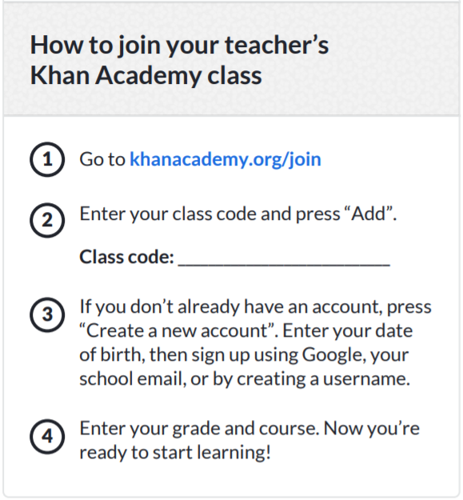
To help us, I’ve created a class in Khan Academy with assignments and unit tests for each of the 3 units we have completed so far. We will use Khan Academy as our review as well as give you an opportunity to AMP an assessment where you scored less than a 69.
You will need to join our class!

Once enrolled in our class, you will be choosing one unit to focus your efforts on this week (Unit checklists are attached to the email with this and posted on CANVAS). Based on your progress report, choose the unit with the lowest test score. This is the Unit Checklist you will use and the Unit you will focus on this week. The due dates on the list are how I suggest you spend your time and the due dates on Khan academy don’t mean anything. THE ACTUAL DUE DATE FOR THIS OPPORTUNITY IS SUNDAY APRIL 12TH.
Once you join Khan Academy you will see no assignments until I accept you. You are welcome to send me a remind or email when you join so I know to accept you. Within Khan Academy, you should see an assignments tab on the left hand side (for laptops/computers/tablets) or if on a SMART phone it is automatically at the top of your khan academy home screen. Based on the unit you select, start at the top of the checklist and complete the Assignments for that unit within Khan Academy. If at any point, you find yourself struggling with the material, there are hints and video help linked in the assignments. Please use them to help master the material. The videos and hints will walk you through each problem style, step-by-step. You may retake an assignment as many times as you need to really learn the concepts. At the end of each unit, there is a unit test. If you are AMPing the unit (i.e. scored less than a 69), this unit test will serve as your AMP. Otherwise, this is just extra practice to help keep you sharp for after Spring Break.
As I’m typing this, I realize it is a lot of information without us being able to meet face to face. I’d like to make myself available to you and your parents via a ZOOM meeting to go over all of this and give you a chance to ask questions. Know in advance that I haven’t been told anything about grades, EOC’s, etc. (we usually find out when you do), but I’d be happy to talk you through the registration process on Khan and what my expectations are moving forward. With all the different schedules, I’d like to offer 2 options.

ZOOM Meeting for students and parents Monday night at 8:00PM or Tuesday morning at 9:00AM.
ZOOM is a very easy to use video-conferencing software that is free. It allows me to use video to share my screen and talk you through all the things discussed above. You can use a laptop/tablet/or smartphone to call in and participate. Just follow the instructions in the link. We have been using ZOOM for department meetings and it has gone really well.
Adam Bryant _ Staff - CaryHS is inviting you to a scheduled Zoom meeting.
Topic: Math 3 Khan Academy Review Week

Monday Night 8PM
Join Zoom Meeting
https://zoom.us/j/271392991
Meeting ID: 271 392 991
Tuesday Morning 9AM
Join Zoom Meeting
https://zoom.us/j/502204618
Meeting ID: 502 204 618
Ok. I think that’s everything for now. Please choose a Unit Checklist from the email or CANVAS, join Khan Academy, and get started on your assignments. You got this!!!!
Work Hard,
Adam Bryant
abryant@wcpss.net

Websites: CANVAS (1st and best option) www.chsmath3.weebly.com and www.khanacademy.org
Remind: text @mrbryant2 to 81010

Reminder: You are only picking one Unit for this week!
Unit 1 | Unit 2A | Unit 2B
Unit 1 – Piecewise and Absolute Value Checklist | Unit 2A – Functions and Inverse Checklist | Unit 2B – Exponentials and Logarithms Checklist
Unit 1 Project – A Piecewise Story | Unit 2A Project | Unit 2B Project – Let’s Buy a Car

